subject='subj04NN'

fif_file = os.path.join(data_dir,'subj04NN_sess01_raw_tsss.fif')

mne.gui.coregistration(subject=subject,inst=inst)

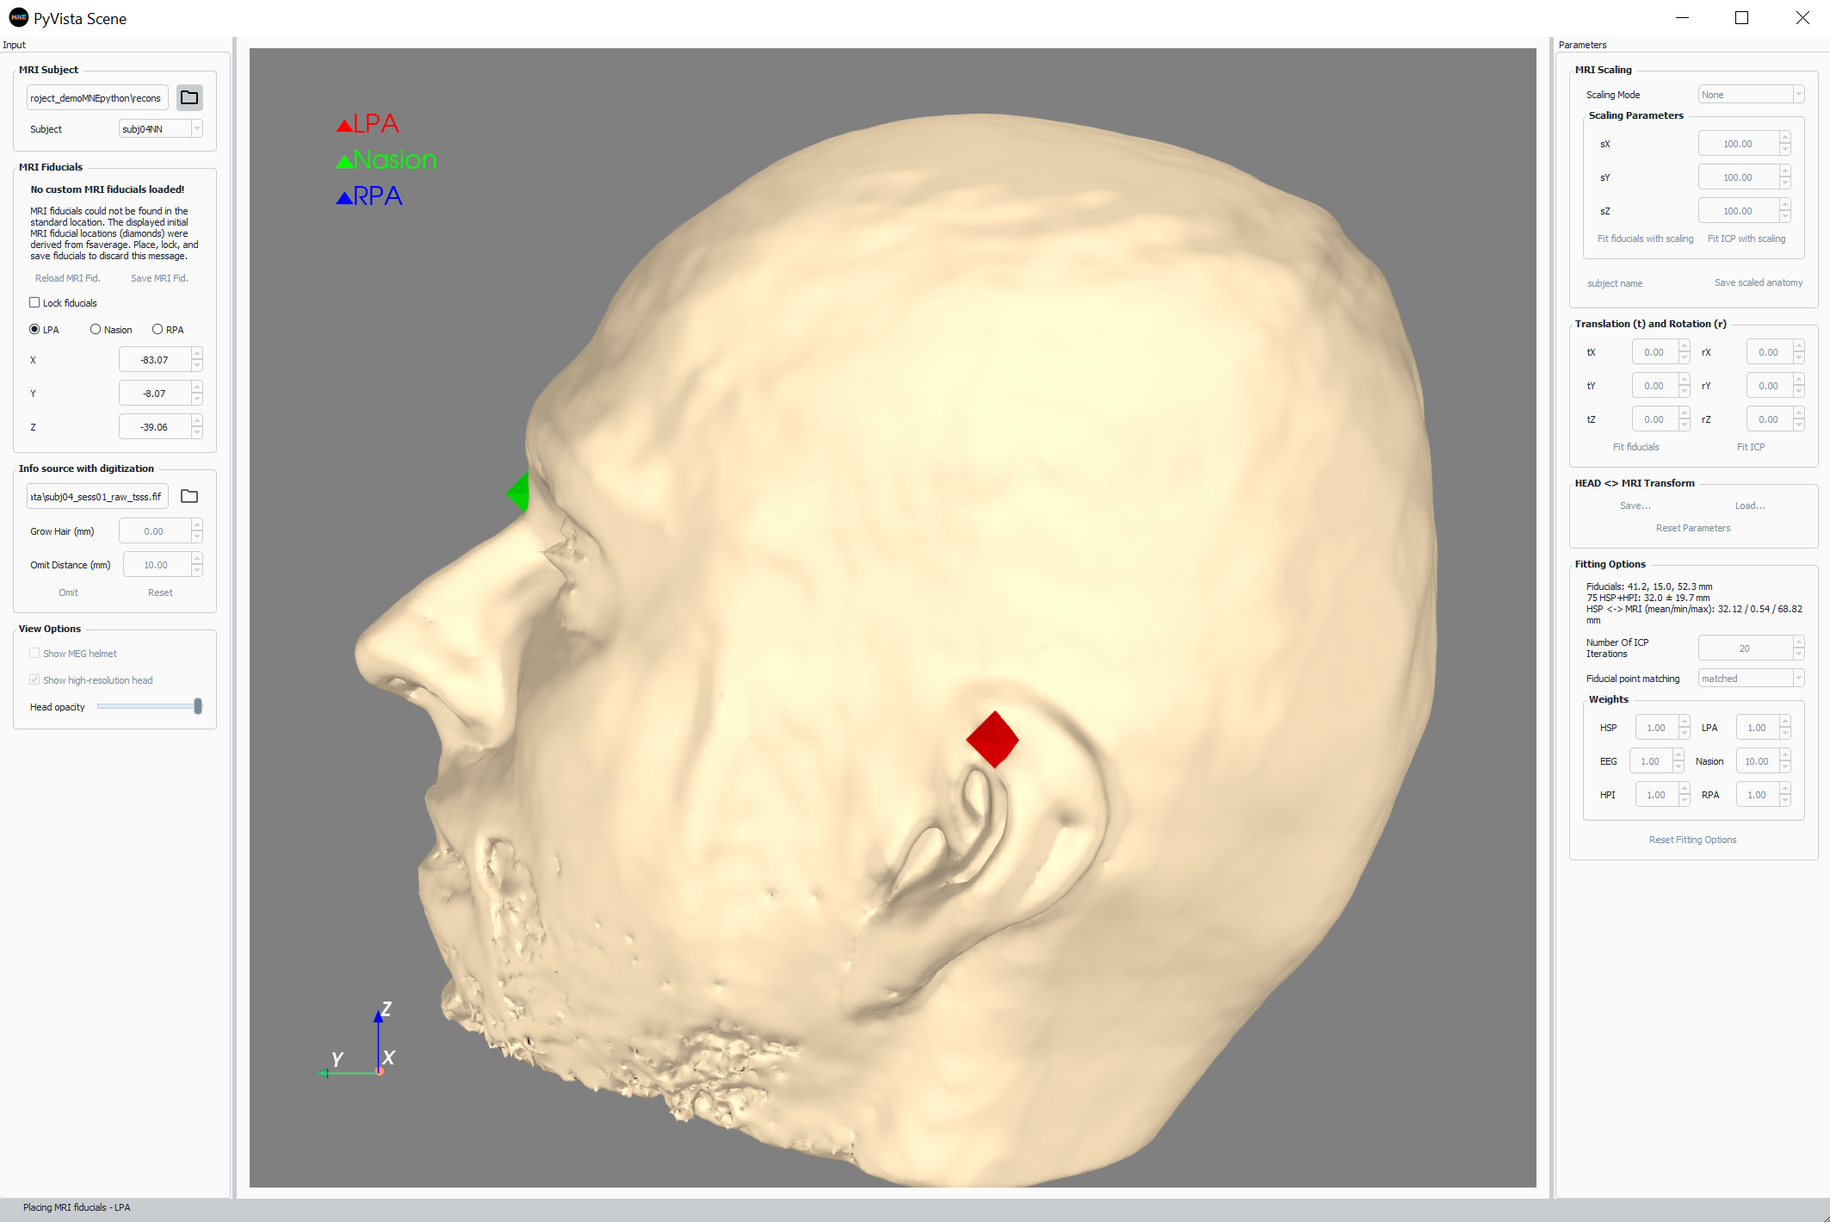

Right click on surface to denote LPA:

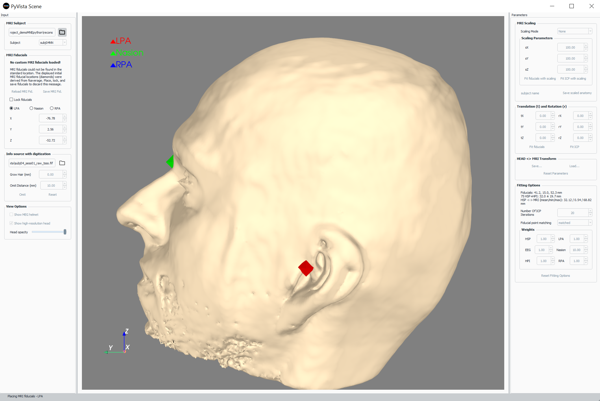

Select ‘Nasion’ from bullet list:

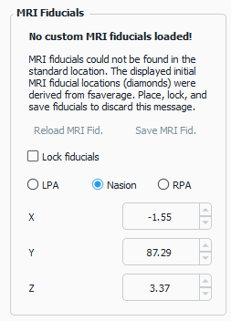

Right click on surface to denote Nasion:

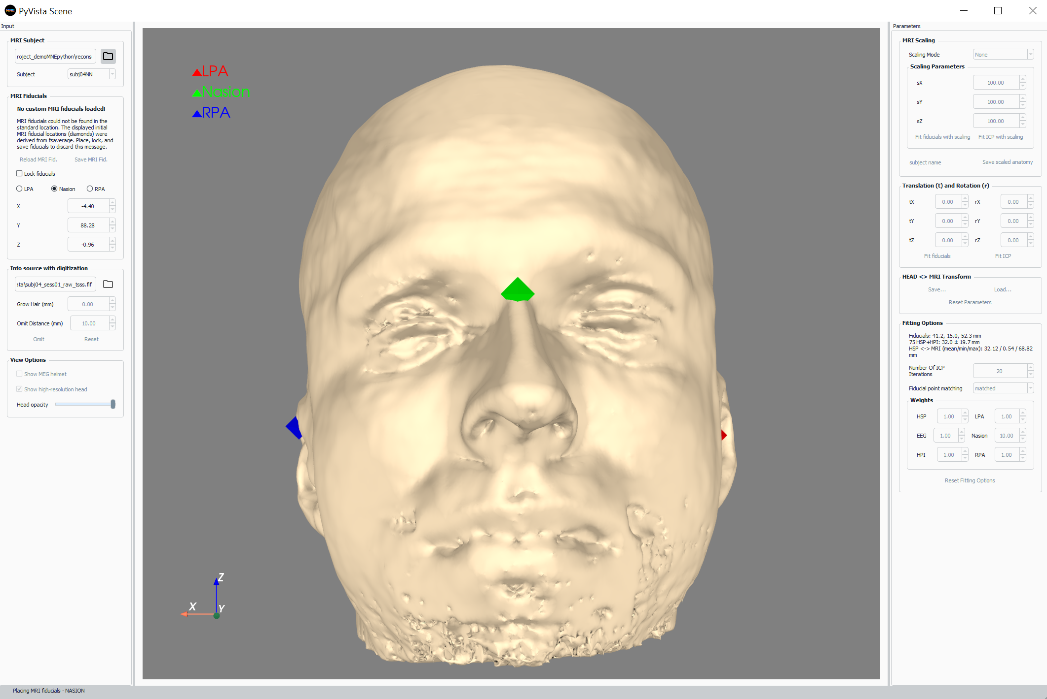

Select ‘RPA from bullet list:

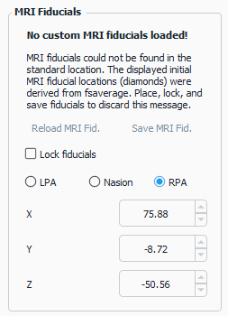

Right click on surface to denote RPA:

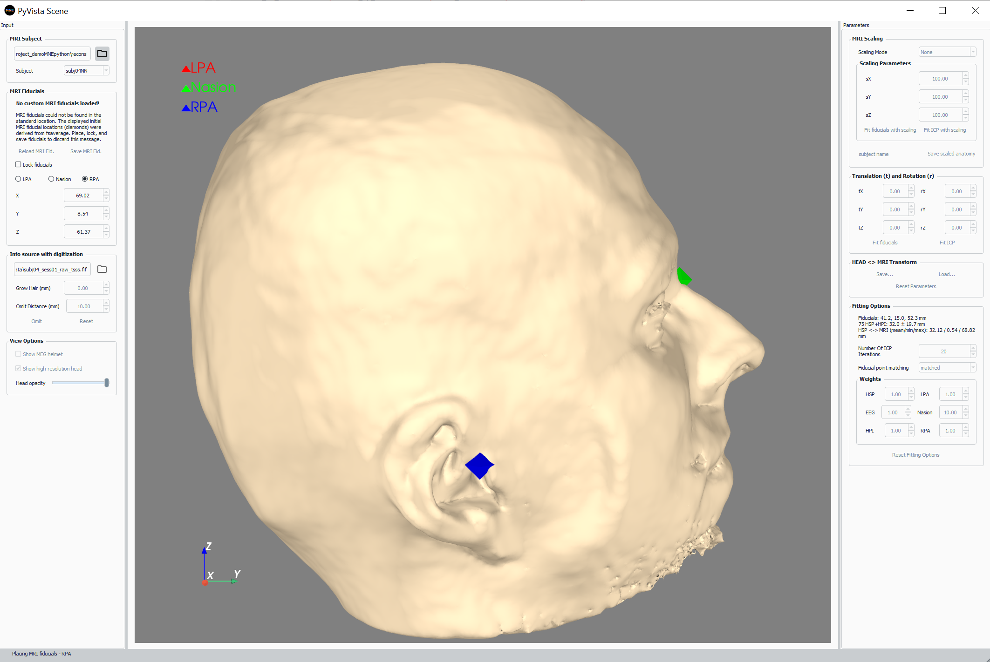

Lock fiducials:

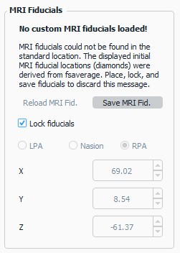

Click ‘Save MRI Fid.’ This will create a <subject>-fiducials.fif file inside the bem folder of the subject freesurfer directory.

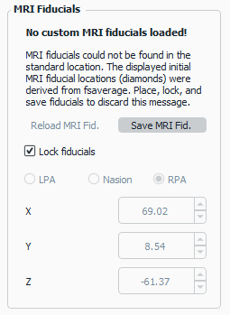

Press Fit fiducials. Then press Fit ICP (a few times, as appropriate to refine registration)

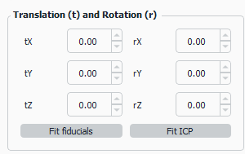

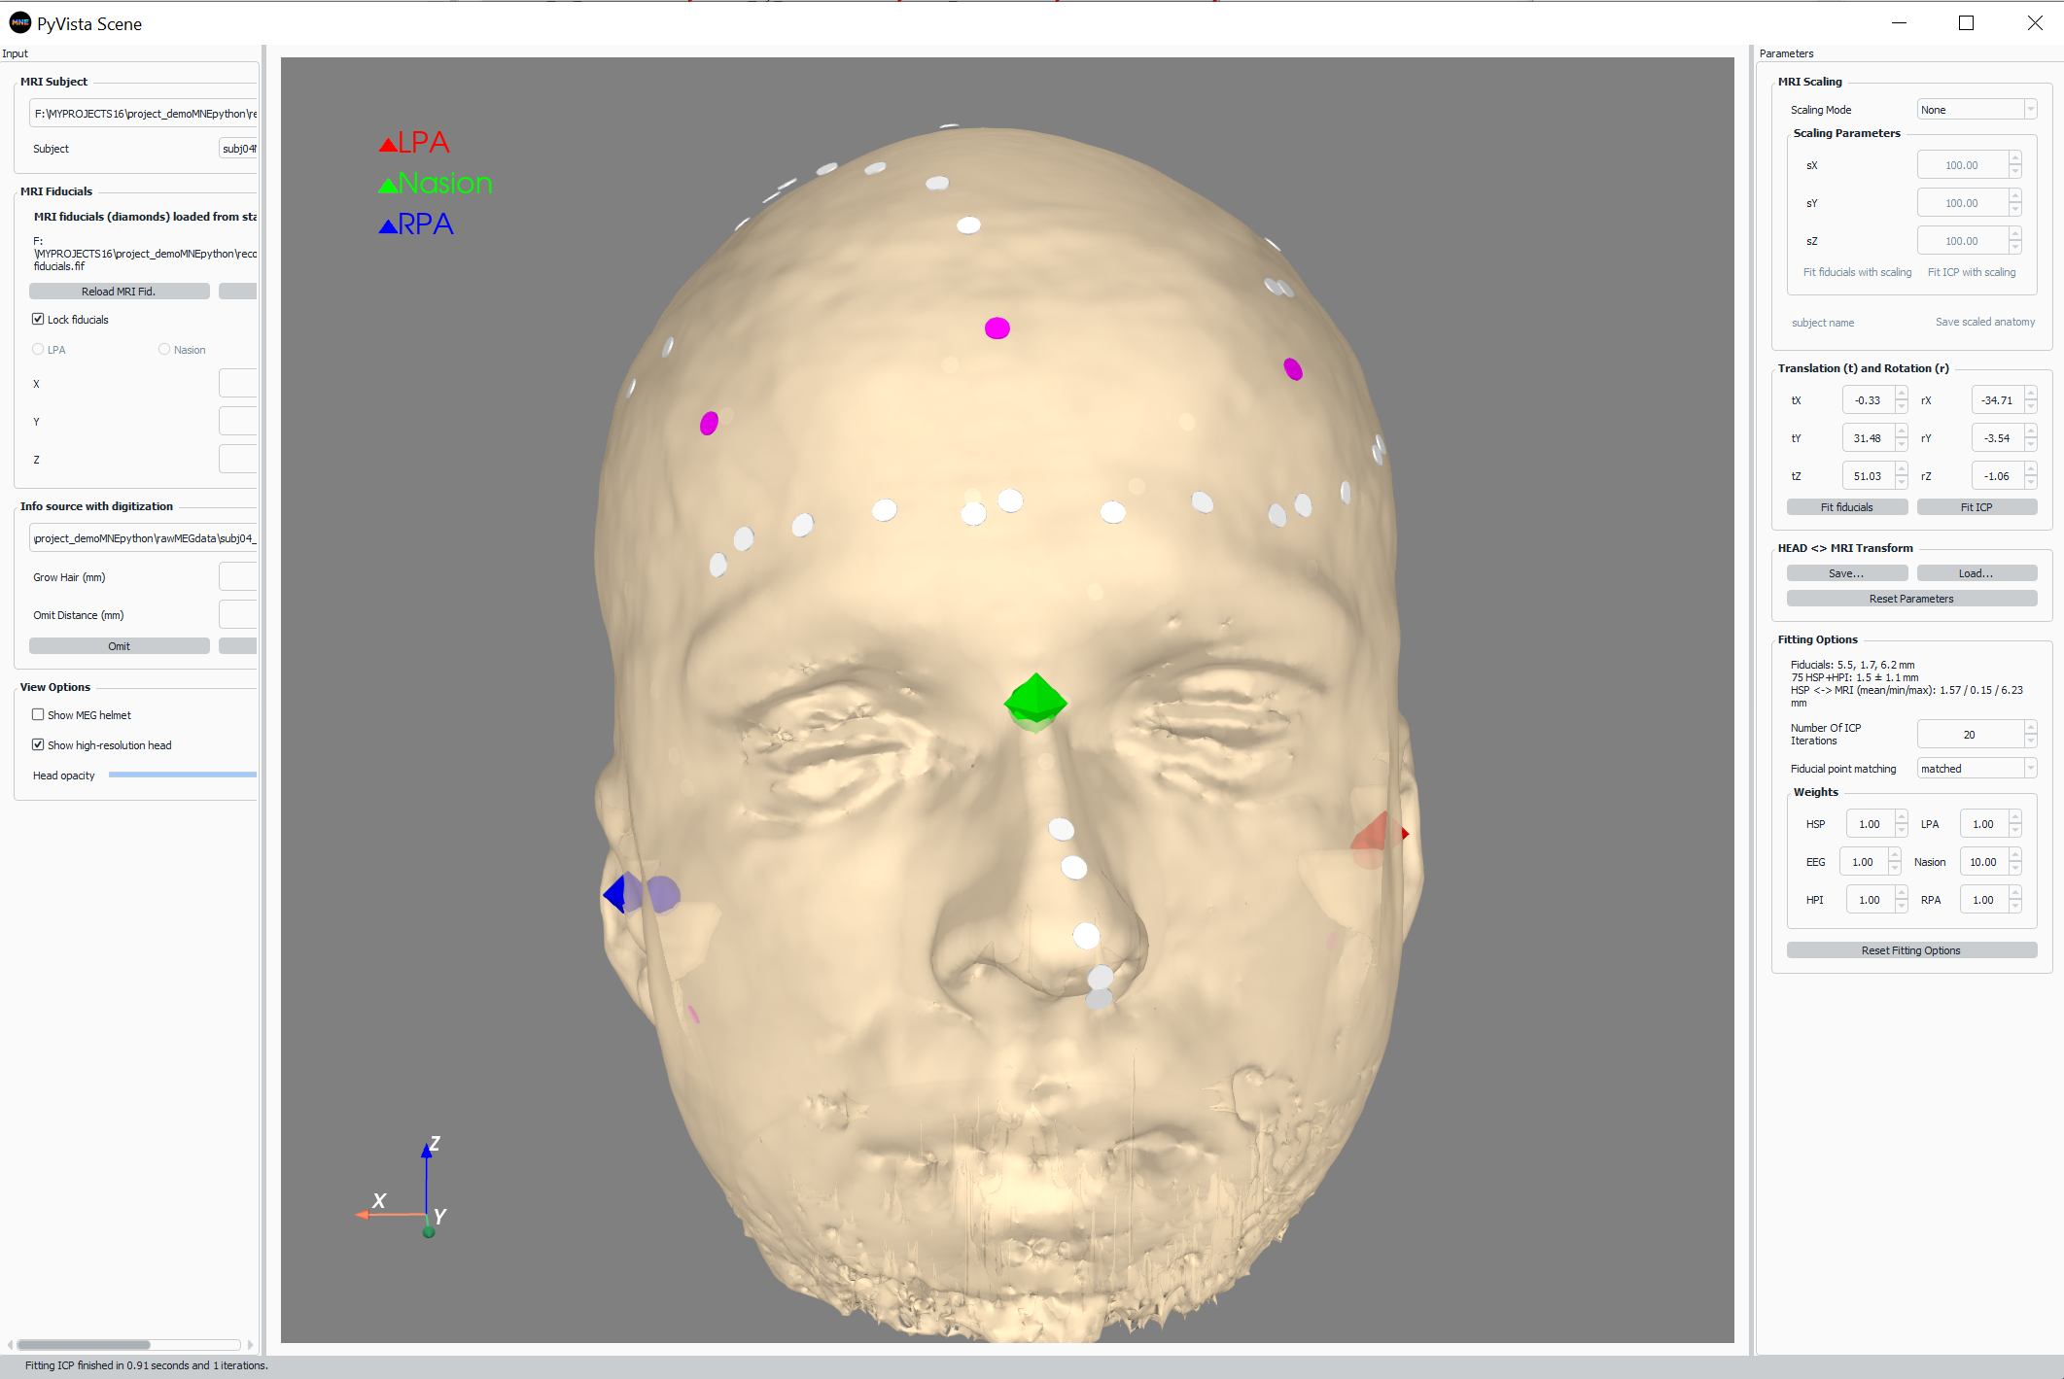

Press ‘Save…’ to save registration.

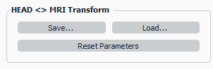

Save the file next to the ‘fif’ file with a name that relates to the subject anatomy, including the -trans.fif at the end (e.g. subj04NN-trans.fif).

